Redistricting Amendment
Voting Begins Friday, March 6th
“Election” day is Tuesday, April 21st from 6 a.m. - 7 p.m.

Ballot Question: “Should the Constitution of Virginia be amended to allow the General Assembly to temporarily adopt new congressional districts to restore fairness in the upcoming elections, while ensuring Virginia’s standard restricting process resume for all future redistricting after the 2030 census?”

What is does “restore fairness” mean?

In 2020, Virginia voted to amend the Virginia Constitution to have electoral district lines drawn by a bipartisan committee. This legislation was approved by an overwhelming majority of the voters. It passed by a margin of greater than one million votes.

The current Virginia Constitution states:
Districts should be compact and continuous and avoid diluting minority voting power.

Currently, congressional seats are held by 6 democrats and 5 republicans.

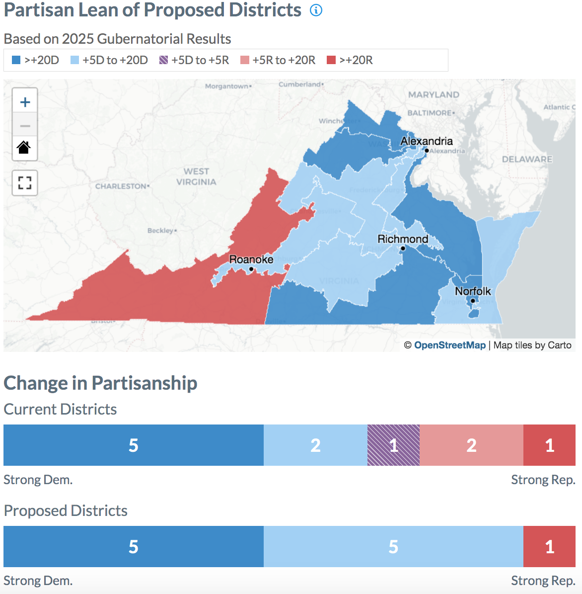
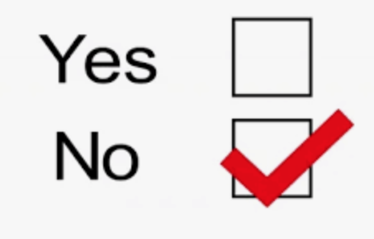
According to VPAP, the new legislative districts would be weighted to change the congressional makeup to 10 democratic seats and 1 republican seat. The proposed lines clearly do NOT reflect compact/continuity and they clearly dilute the minority vote.
10 to 1 is NOT fair. Disenfranchises 48% of Virginia Voters.

Vote NO on April 21st

